Lab 1: Lab Intro and Verilog 2:1 MUX
Lab Worksheets should be filled out during your lab section and then completed
(adding Conclusion Topic responses) and submitted on D2L by Sunday at 11:59pm.
Student Name: Kyle Rush

Lab Worksheet
Complete this sheet as you complete the lab.

Pre-Lab
Section 2.2
- Paste your screenshot below.
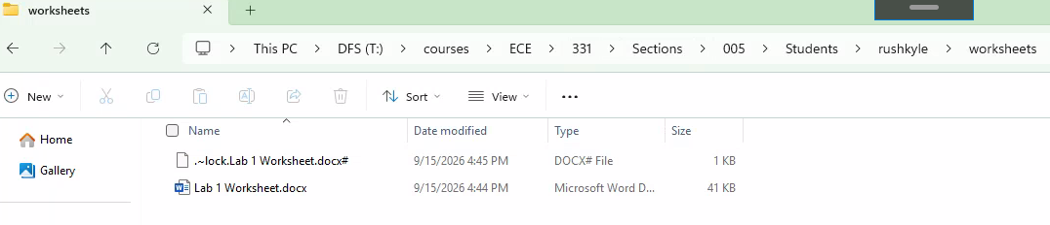
- How many print tokens do you have, and how much of your disk quota are you using?
600 pages per semester on EGR network. Depending on which disk, virtually using none (of any DECS given network drives). <a few megabytes on DFS.
- What are the files in the Lab Manual Instructions and Worksheets directory accessible to all students in ECE331?
total 6016
drwxr-xr-x. 2 kyle kyle 0 Apr 21 08:19 .
drwxr-xr-x. 2 kyle kyle 0 Sep 14 12:52 ..
-rwxr-xr-x. 1 kyle kyle 139777 Nov 17 2025 'Lab 10 Instructions.pdf'
-rwxr-xr-x. 1 kyle kyle 45857 Apr 13 14:34 'Lab 10 Worksheet.docx'
-rwxr-xr-x. 1 kyle kyle 208334 Jan 17 2026 'Lab 1 Instructions.pdf'
-rwxr-xr-x. 1 kyle kyle 66434 Jan 17 2026 'Lab 1 Worksheet.docx'
-rwxr-xr-x. 1 kyle kyle 247665 Jan 17 2026 'Lab 2 Instructions.pdf'
-rwxr-xr-x. 1 kyle kyle 57280 Jan 17 2026 'Lab 2 Worksheet.docx'
-rwxr-xr-x. 1 kyle kyle 484660 Feb 5 2026 'Lab 3 Instructions.pdf'
-rwxr-xr-x. 1 kyle kyle 54774 Feb 5 2026 'Lab 3 Worksheet.docx'
-rwxr-xr-x. 1 kyle kyle 205270 Feb 18 2026 'Lab 4 Instructions.pdf'
-rwxr-xr-x. 1 kyle kyle 46578 Feb 25 2025 'Lab 4 Worksheet.docx'
-rwxr-xr-x. 1 kyle kyle 331954 Mar 6 2026 'Lab 5 Instructions.pdf'
-rwxr-xr-x. 1 kyle kyle 53582 Mar 11 2026 'Lab 5 Worksheet.docx'
-rwxr-xr-x. 1 kyle kyle 753440 Oct 12 2025 'Lab 6 Instructions.pdf'
-rwxr-xr-x. 1 kyle kyle 51448 Oct 14 2025 'Lab 6 Worksheet.docx'
-rwxr-xr-x. 1 kyle kyle 262085 Oct 27 2025 'Lab 7 Instructions.pdf'
-rwxr-xr-x. 1 kyle kyle 48461 Mar 25 16:46 'Lab 7 Worksheet.docx'
-rwxr-xr-x. 1 kyle kyle 268832 Apr 6 17:10 'Lab 8 Instructions.pdf'
-rwxr-xr-x. 1 kyle kyle 62895 Apr 3 23:52 'Lab 8 Worksheet.docx'
-rwxr-xr-x. 1 kyle kyle 154296 Apr 13 2025 'Lab 9 Instructions.pdf'
-rwxr-xr-x. 1 kyle kyle 49662 Apr 6 16:18 'Lab 9 Worksheet.docx'
-rwxr-xr-x. 1 kyle kyle 2520229 Oct 15 2025 'Lab Manual.pdf'
kyle@quack:/media/ece331/courses/ECE/331/Shared/Lab Manual Instructions and Worksheets$
Section 2.3
- Where will you turn in this worksheet?
D2L
- Suppose you have an 8AM lab, but arrive at 8:15. You had your Pre-Lab completed before arriving to lab. Will you get credit for your Pre-Lab?
No credit, since it is past 10 minutes late.
- Suppose you turn in your worksheet on Monday at 11:10AM, but it is complete (with no errors). How many points will you get on your worksheet?
3 points since minus 2 total points because of the 2 hours missed.
- Suppose you attend lab the first week without having activated your DECS account. Will you be able to complete your lab?
No, you need to set that up before hand.
- Note any questions you might have for the TA before continuing with the lab. If you have none, simply write ‘None’.
None
Section 3: Electrical Safety
- Dry skin has a resistance of roughly 160kΩ from fingertip to fingertip. Calculate the current if you were to tough a 240V_{ac} line.
V=IR so 240/160k = 1.5mA RMA
- After current begins to penetrate your skin, your skin’s dielectric strength rapidly decays and only the body’s internal resistance remains. If you do not remove yourself from the 240V_{ac} system, is there a significant risk? Explain, referencing the likely reaction based on information in the lab manual.
Yes, since your muscles can contract around the wire and keep holding onto it, which can cause burns or death.

- You plug in the USB cord to your system and it lights up, indicating that there is power. Then you move the board, and the lights flicker on and off. Your neighbor says it’s fine; it’s just 5V, and you can just put a little sideways tension on the cord to keep it connected properly. What should you do?
Replace the cable or talk to a TA to find a reasonable solution. Broken cables are a bad sign and can cause shorts or damage to the board or other systems.
Section 4: Verilog and Vivado Intro
- Why are we using Verilog instead of VHDL?
We use Verilog instead of VHDL because it has a similar syntax to C, which is a prerequisite.
- What is the difference between a wire and a reg? When will we use each one?
Reg represents a variable similar to C, whereas a wire represents an output/input that can be set. Wires use continuous assignment to determine their value (using logical/bitwise operators), whereas registers are procedurally assigned similar to programmatic coding like C.
- What are the three biggest mistakes students make when working with Verilog in this course?
Misnaming (including capitalization) items, instances, modules, registers, or wires.
- What is an IDE?
Integrated development environment. Used for developing and testing programs and structures within a project.
- Which IDE are we using, and why?
Vivado, because it supports Verilog debugging, testing, development, simulation, and deployment.
- What four functions will our IDE serve?
Allows us to create modules, instantiate them into larger modules, analyze them in simulation, and synthesize our code.
- How will you primarily be accessing Vivado in this course?
Through DECS computers or web remote access.
- What type of assign statements will we be using?
We will use assign to continuously assign to wires and use just regular assignment via = operator within procedural blocks.
- A student uses the following instantiation to instantiate ‘andModule’ in a testbench. What are the two problems, according to our naming convention for this course?
andModule andModule_tb(.A(a), .B(b), .OUT(out));
It should be reversed in the argument casing. This means that the defined param (A, B, OUT) in the module should be lowercase, whilst the test bench variables (a, b, out) should be uppercase. The module test name should be called andModule_test not suffix _tb.
- What is the functional difference between the two following Verilog segments?
  - assign A= B & C | D;
  - wire X
assign X= B & C;
assign A = X | D;
Functionally zero difference, though it releases 1 wire to use method a.
- Write a Verilog assign statement equivalent to x = (a OR b) AND c
assign x = (a | b) & c;
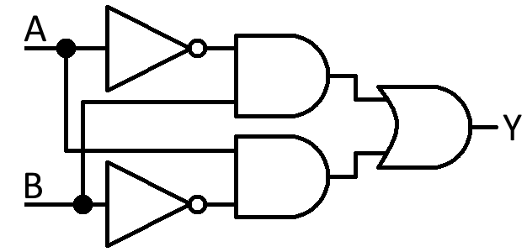
- What was wrong with the following statement in the Lab Manual?
assign y = A & B;
Wires A and B do not exist, as they were defined lowercase a and lowercase b.
- Write a Verilog assign statement, or series of statements, to describe the logic diagram to the right. You may create wires as needed.
wire a_inter;
wire b_inter;
assign a_inter = ~A & B;
assign b_inter = A & ~B;
assign y = a_inter | b_inter;

Section 5: Coding and Testing the 2:1 MUX
- What are the input and output types in the testbench we created?

Inputs are registers while the output is a wire type.
- Fill in the truth table.
S0 | In1 | In0 | Theoretical out | Simulated out
0 | 0 | 0 | 0 | 0
0 | 0 | 1 | 1 | 1
0 | 1 | 0 | 0 | 0
0 | 1 | 1 | 1 | 1
1 | 0 | 0 | 0 | 0
1 | 0 | 1 | 0 | 0
1 | 1 | 0 | 1 | 1
1 | 1 | 1 | 1 | 1

- You finish the simulation and you see that IN0 is red. What is the likely reason for this?
Because I right clicked on the signal and changed it to red.
- Paste a screenshot of your simulated results below.
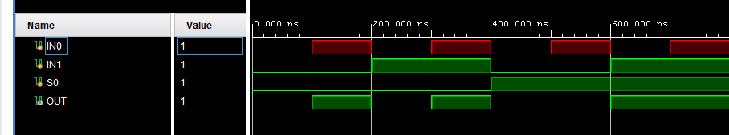
Post-Lab:
- Thinking about the ECE331 lab process as described in the LabManual, what aspect of each lab do you expect to take the most time? Why?
Filling in questions in the lab worksheet takes the most time, including pre-lab and post-lab work. This is because for this lab I had to go back and look through the manual and instructions to find the exact answer for some of the questions.
- Briefly describe a potential electrical safety risk that you feel you should be cautious of in the ECE331 lab.
We deal with low voltage circuits, so an electrical safety risk would be overvolting a circuit and causing an MCU to fail. The best thing to do in that situation is to turn off the power supply and unplug any circuitry.
- Based on your limited knowledge of Verilog, how would you describe, in your own words, the purpose or utility of a hardware description language (HDL)? What does it allow us to do that we otherwise could not? Consider what you expect to learn in ECE331 and why Verilog is covered in this class.
You are allowed to look up some information before forming your response; just make sure the final response is in your own words.
It allows us to describe digital logic closer to the hardware level than any programming language could. It allows us to design and simulate circuits before testing on real hardware and to debug easily with lower level hardware. Verilog is closer to C syntax and such allows us to focus on function rather than relearning another syntax like we would have to with VHDL.
- Thinking back to Lab 1 overall, what aspect of working with Verilog or Vivado would you define as the most challenging? If possible describe why or what specific aspect were challenging.
All of this lab was done in ECE230 in a similar manner, so no part of Vivado was unfamiliar or challenging. The most challenging was actually implementing the logic.
- (This one may be challenging with your limited knowledge of Verilog, but give it your best shot.) In a Verilog testbench, why do we declare inputs as reg and outputs as wire?
We are reading values from outputs, so we do not want the testbench file to change the value. We then feed it into our instance because we want it to directly assign output to said wire. We change inputs in a procedural manner, so we need to declare them as registers to do so to then pipe into the instance.
- If you wanted to create a library of Verilog digital gate primitive cells that would allow you to design a wide array of digital circuits all built on these primate gates, which logic gates (e.g., AND) would you include in your primitive cell library? Why? There is no single correct answer; just think it through and answer to the best of your ability/knowledge.
NAND and NOR are the building blocks of all digital logic because they can construct any logic from just these two blocks. I would also include the other basic ones if I could like NOT, AND, OR, XOR, and XNOR.
- In your own words, what is the role that a MUX plays in digital designs? Can you think of a specific possible scenario where a MUX should be used? Even if you are not entirely sure, provide your best guess.
It is a digital selector switch, and has a wide variety of uses such like which register to use. Have A, B, C registers that can be selected using two bits in a 3:1 mux (4:1 really).
- What could we have done to make this lab run more smoothly?
Nothing much really, it was good.

